Acceptance Testing
UAT Execution & Report Submission
Date | 18 February 2026
Team ID | LTVIP2026TMIDS24123
Project Name | Civil Engineering Insight Studio
Maximum Marks | 4 Marks

Purpose of Document
The purpose of this document is to describe the test coverage, defect status, and overall system stability of the Customer Support System (CSS) at the time of release to User Acceptance Testing (UAT).
This report confirms that:
- All major functional modules (Registration, Login, Dashboard, Complaint Management, Role Management) are tested.
- Critical and high-severity defects have been resolved.
- The system is ready for user validation and approval.

Defect Analysis
This report shows the number of resolved or closed bugs at each severity level and their resolution status.
Resolution | Severity 1 (Critical) | Severity 2 (High) | Severity 3 (Medium) | Severity 4 (Low) | Subtotal
By Design | 2 | 3 | 1 | 2 | 8
Duplicate | 1 | 0 | 1 | 0 | 2
External | 0 | 1 | 0 | 1 | 2
Fixed | 6 | 5 | 4 | 8 | 23
Not Reproduced | 0 | 0 | 1 | 0 | 1
Skipped | 0 | 0 | 1 | 1 | 2
Won’t Fix | 0 | 1 | 2 | 1 | 4
Totals | 9 | 10 | 10 | 13 | 42

Defect Severity Meaning
- Severity 1 → System crash / Login failure
- Severity 2 → Major functionality not working
- Severity 3 → Minor functional issue
- Severity 4 → UI / Cosmetic issue

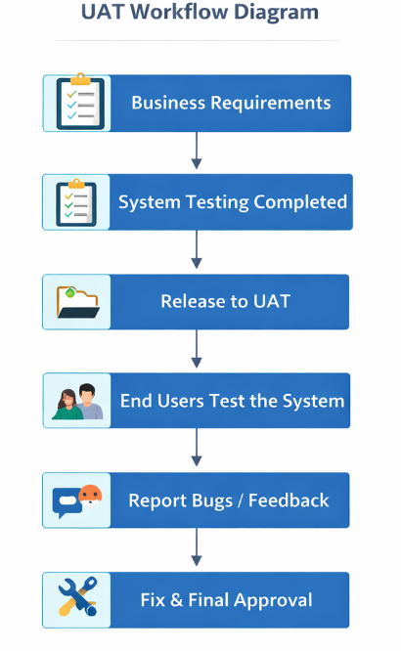

Test Case Analysis
This report shows the number of test cases that passed, failed, or remained untested during UAT.
Section | Total Cases | Not Tested | Fail | Pass
Registration & Login | 12 | 0 | 0 | 12
Dashboard | 10 | 0 | 0 | 10
Complaint Management | 18 | 0 | 1 | 17
Agent Management | 8 | 0 | 0 | 8
Admin Control Panel | 7 | 0 | 0 | 7
Security (Role Access) | 5 | 0 | 0 | 5
Performance & Load | 5 | 0 | 0 | 5
Total | 65 | 0 | 1 | 64

